* 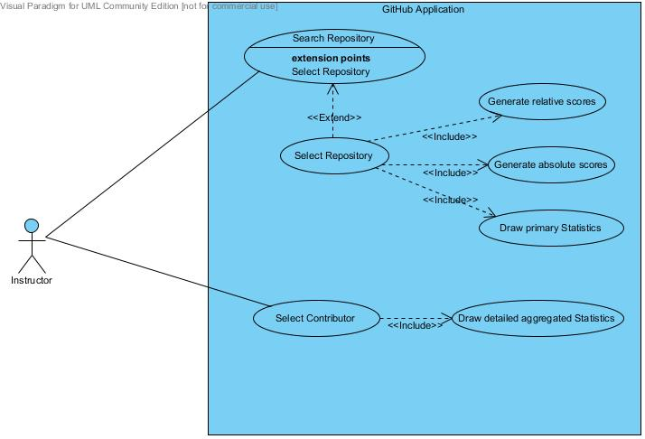**USE CASE DIAGRAM**

Figure 1: Use Case Diagram

* **USE CASE SPECIFCATION**

|  |  |
| --- | --- |
| Use case Name: | Search Repository |
| Brief Description | Look for a certain repository by its full or partial name |
| Primary Actors | Instructor/Professor |
| Triggers | Instructor clicks the search button[1] |
| Preconditions: | |
| Post-conditions: A list of available repositories is shown | |
| Main Success (Normal) Scenario: | |
| Actor Action | System (GiHub Application) Response |
| 1. Instructor enters search keywords | 2. System searches for available repositories |
|  | 3. System shows the available repositories in a list |
| Alternative Flows:  3. No repository exists. The system will show a “no repository found” message | |

USE CASE SPEC. 1: Search Repository

|  |  |
| --- | --- |
| Use case Name: | Select Repository |
| Brief Description | Select a repository from the list |
| Primary Actors | Instructor/Professor |
| Triggers | Instructor selects a repository from the list |
| Preconditions: The repository is already on the list | |
| Post-conditions: Users for the selected repository are displayed | |
| Main Success (Normal) Scenario: | |
| Actor Action | System Response |
| 1. Instructor selects a repository | 1. System displays users for this repository along with their primary statistics |
|  | 1. System initiates “generate absolute score” use case |
|  | 1. System initiates “generate relative score” use case |

USE CASE SPEC. 2: Select Repository

|  |  |
| --- | --- |
| Use case Name: | Draw primary statistics |
| Brief Description | Display the primary statistics directly form the Github statistics |
| Primary Actors | Instructor/Professor |
| Triggers | Instructor selects a repository from the listing thus causing this use case to initiate |
| Preconditions: The repository is already on the list | |
| Post-conditions: Primary statistics are shown along with their corresponding user | |
| Main Success (Normal) Scenario: | |
| Actor Action | System Response |
|  | 1. System access and retrieve contributor’s statistics |
|  | 1. System initiates “generate relative score” use case |

USE CASE SPEC. : Draw Primary Statistics

|  |  |
| --- | --- |
| Use case Name: | Select Contributor |
| Brief Description | Select a Contributor (Student) from the list |
| Primary Actors | Instructor/Professor |
| Triggers | Instructor selects a contributor from the list |
| Preconditions: Instructor has already selected a repository | |
| Post-conditions: Textual data that they are generated when contributor commits | |
| Main Success (Normal) Scenario: | |
| Actor Action | System Response |
| 1. Instructor selects a contributor | 1. System displays (primary/textual statistics for this particular contributor) |

USE CASE SPEC. 4: Select Contributor

|  |  |
| --- | --- |
| Use case Name: | Generate absolute scores |
| Brief Description | Generate score for every single contributor according to his progress compared to a certain criteria[2] |
| Primary Actors | Instructor |
| Triggers | Instructor clicks on the repository in the search resultsindirectly cause this use case to initiate |
| Preconditions:  1. At least one contributor exists | |
| Post-conditions:  1. A list of the absolute scores is displayed in a certain format[3] | |
| Main Success (Normal) Scenario: | |
| Actor Action | System Response |
|  | 1. The system access and collects each contributor’s statistics |
|  | 2. The system calculateseach contributor’s score from the data collected depending on a certain criteria |
|  | 3. The system displays a list of the scores to the instructor |

USE CASE SPEC. 5: Generate absolute scores

|  |  |
| --- | --- |
| Use case Name: | Generate relative scores |
| Brief Description | Generate score for every single contributor according to his progress compared to the best score achieved by his colleagues |
| Primary Actors | Instructor |
| Triggers | Instructor clicks on the repository in the search resultsindirectly cause this use case to initiate |
| Preconditions:  1. At least one contributor exists | |
| Post-conditions:  1. A list of the relative scores is displayed in a certain format | |
| Main Success (Normal) Scenario: | |
| Actor Action | System Response |
|  | 1. The system access and collects each contributor statistics |
|  | 2. The system calculates the score for each contributor from the data collected and depending on a certain criteria |
|  | 3. The system search for the highest score |
|  | 4. The system apply the following equation $score= \frac{score}{bestScore}*100$ |
|  | 5. The system displays a list of the scores to the instructor |
| Alternative Flows:  3. Only one contributor exists. Jump to step 5 | |

USE CASE SPEC. 6: Generate relative scores

|  |  |
| --- | --- |
| Use case Name: | Draw detailed aggregated statistics |
| Brief Description | Draw advanced statistics using the available primary statistics following predefined rules[4] |
| Primary Actors | Instructor |
| Triggers | Instructor click on the contributor indirectly cause this use case to initiate |
| Preconditions:  1. At least one contributor exists | |
| Post-conditions:  1. The full detailed statistics is shown | |
| Main Success (Normal) Scenario: | |
| Actor Action | System Response |
|  | 1. The system access and collects each contributor statistics |
|  | 2. The system apply a predefined algorithm to come up with a new statistics |
|  | 3. The system display the results |

USE CASE SPEC. 7: Draw aggregated statistics

1. In case on enabled auto-complete then writing in the search box will be the trigger
2. The criteria – The assessment algorithm – is not yet decided
3. The format is not yet decided
4. To be defined later